Union Station Haunted?

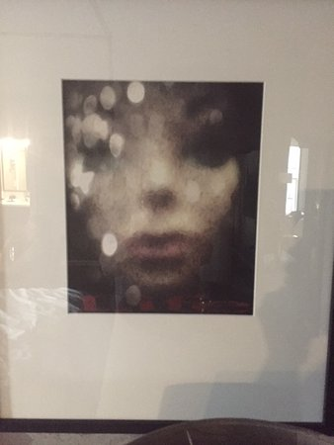

Room 711 at the Union Station is permanently occupied. Why is this? Some say it is haunted by the ghost of Abigail. The story says that Abigail said goodbye to her fiancée at the train stop at Union Station before he left to fight in the World War. They promised to meet at the same train stop when he returned. Abigail waited every day at the train stop. When the war ended, Abigail’s fiancée did not come home. She started to realize her love was not coming home. In Abigail’s grief, she threw herself in front of a moving train. Since then, stories have circulated that lights will turn on with nobody else in the room. Furniture moves for no apparent reason. Pictures guests take have a ghostly silhouette in the background. Some claim this is Abigail searching for her lost lover. Do you believe this story? How could we check? Records do not mention Abigail’s last name. Below is a table listing all of the names of people starting with “A” that were buried in the Nashville City Cemetery during World War I. Could one of these be Abigail? Visit the Nashville City Cemetery to do your own investigating!!!!!!

|  |  |  |  |
| --- | --- | --- | --- |
| Card, A. C., Mrs. | |  |  |
| 1914 |  |  |  |
| Holt, Bettie A. | |  |  |
| 1916 |  |  |  |
| McAlister, Mary A. | |  |  |
| 1915 |  |  |  |
| Newman, J. A. | |  |  |
| 1914 |  |  |  |